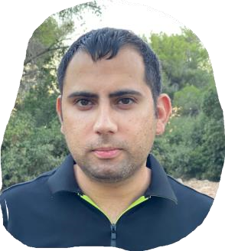

KHALED
NAAMNEH

2
5
/04/1983

Electrical Practical Engineer

PROFILE

A
s a
n

Electrical Practical Engineer, I
have worked for 14 years as an
Instrument & Electrical Technician and
therefore, have a strong technical.
background. I have
experience in
operational data logging and
watchkeeping on main and auxiliary
machinery. I also have experience in
troubleshooting and doing
maintenance of machinery,
generators, boilers, purifiers, pumps,
and freshwater generators. These
experiences are
comprised of
materials order, storage,
maintenance, planning, maintenance
schedules, etc.
.

CONTACT

PHONE:

+972
-
525577185

LINKEDIN:

linkedin.com/in/khaled
-
naamneh
-
8764b51b5

EMAIL:

Naamneh5@gmail.com

Address

Jalami Road, Arraba 30812

Israel

LANGUAGES

Arabic
–

Advanced

Hebrew
–

Advanced

English
-

Intermediate

WORK EXPERIENCE

Instrument

&

Electrical Technician

noble energy
Mediterranean

ltd

JUN
201
9
–
Present

Preventive maintenance, handling electrical faults
.

Instrument

&

Electrical Technician

PHOENICIA Glass industry

JAN 2016
–

2019

Preventive maintenance, handling of electrical faults, construction and
expansion of machines and production lines
.

Instrument

&

Electrical Technician

MILOTAL Frozen
Vegetables

JUN 2005
–

2015

Preventive maintenance, handling of electrical faults, construction and
expansion of machines and production lines
.

EDUCATION

ELECTRICAL PRACTICL ENGEINEERING

2012

THE
NATIONAL COLLEGE
-

SAKHNIN
COLLEGES FOR SCIENCES AND
TECHNOLOGY

CERTIFICATIONS & COURSES

•

high Voltage System operator

•

Fire and Smoke Detection Systems Operator

•

Steam Boiler and Heating Boiler Operator

ACHIEVEMENTS

Over the course of
several years, I taught several subjects in the
field of industrial electricity to engineering students, as an assistant
in laboratories and practical workshops in colleges

